Event Planning Guide

Thank you for your interest in running an event. Events help to bring our community together, make Whakatū Nelson a more interesting place to live and contribute to a vibrant economy. Nelson City Council appreciates the hard work and creative energy of our events community and wants to do everything we can to help your event run smoothly.
This guide has been put together to help guide your thinking as you plan all the aspects of your event.
How to use this guide?
As an event organiser, you are responsible for planning and managing risk at your event. This guide is provided to assist you to plan and deliver a safe, healthy, and operationally successful event, and will complement your other plans for security programming, marketing, funding etc. This guide is provided as advice only, it remains your responsibility to ensure that you are aware of regulatory requirements. It is strongly recommended that you contact Nelson City Council for information and advice where you have any questions or uncertainty.
To help you plan for your event a template is provided below, to take you through the necessary steps. Remember that you are responsible for identifying additional content, editing wording to reflect your management approach, and adding any and all information critical to your event operations under the Health and Safety at Work Act 2015 (HSWA).

Notes before you start:
- Though It may look long, this advance planning guide will help you to consider all aspects of your event and support you in delivering a successful and safe event.
- Not all of this template may be relevant for you depending on the size and nature of your event.
- This guide is a suggested tool for your reference in planning your event operations. You are welcome to develop your own documentation should you choose not to use this template.
- The event safety guide should be used as a reference point for the level and type of information required within this or any other health and safety documentation.
- Grey text indicates where specific information about your event must be inserted.
- Sample information is placed throughout the template for reference only and should be deleted and replaced with information specific to your event.
- Sections 1 – 6 ask for operational information that describes your event and demonstrates, in a general sense, how you are going to deliver a safe event environment.
- Section 7 suggests headings and content for more detailed plans or procedures for managing risks identified through your risk control planning (Section 6).
- Section 8 provides example appendices i.e., forms, definitions, and a sample risk management framework relevant to your event.

If you have questions about Council Consents after reading this guide, please contact our Customer Services Centre: 03 546 0200

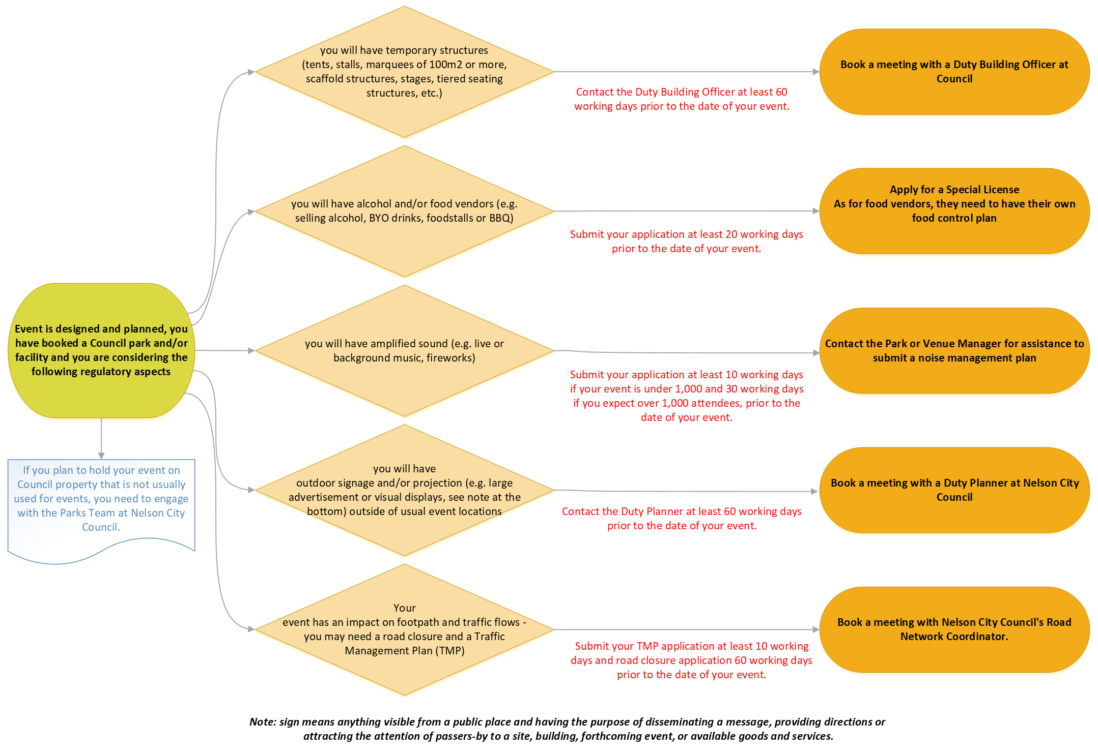
YOUR EVENT NAME operations plan

Purpose
This document outlines how YOUR ORGANISATION NAME OR INDIVIDUAL’S NAME plans to take all practicable steps to deliver a safe and therefore enjoyable event experience at EVENT NAME, DATE AND LOCATION.
We/I understand and accept that under the Health and Safety at Work Act 2015 (HSWA), ORGANISATION/OR ORGANISER NAME, has at all times a duty of care to ensure the health and safety of all event participants and spectators, event staff, contractors, subcontractors, volunteers, other event delivery participants such as sponsors, and any persons legally entitled to be at or in the vicinity of the event site.

Name:
Role:
Date:
Signature:

EVENT HEALTH AND SAFETY COMMITMENT
You will consider the following:
- Have a risk management process in place for identifying, documenting, assessing, managing, and reviewing event risks;
- Provide event health and safety information to all event stakeholders (FENZ, Police, St John, Council, etc.) through pre- planning meetings, site inductions, event signage, event day briefings and event day incident reporting;
- Have clear health and safety roles and responsibilities for the event’s delivery team (including contractors, volunteers, delivery partners);
- Have clear lines of communication and consultation with contractors (PCBUs¹)
- Have an agreed process for reporting and investigating incidents;
- Plan event day site checks and monitoring, that feed into daily/end of event debriefs to ensure continuous improvement; and
- Comply with all relevant legislation, regulations, codes of practice and industry standards.

EVENT DETAILS

Event name:
Event summary & scope: (briefly outline the nature and scope of the event and activity on the event site)
Site description: (e.g. name, address, key features)
Event dates & times:  Note: If you have a maritime event, include set up and pack down time required on water and consider tide times. | Pack-in date/s: | Pack-in times/s:
 | Event start date/s: | Event end date/s:
 | Event start time: Event Start time: | Event end time: Event end time:
 | Pack-out date/s: | Pack-out time/s:
Event organiser contact details: | Contact name:
 | Mobile:  E: | Address:

1 PCBU – Person conducting a business or undertaking ref Health and Safety at Work Act 2015

Alternative contact: | Contact name:
 | Mobile:  E: | Address:

Total site capacity: Number of people that the site can accommodate at any one time
Anticipated participation numbers (workers/spectators etc.) on the event site at any one time:
Anticipated Participants and spectators |  | Yes | No | Expected number of persons:
Participants
Employees
Spectators/patrons
Contractors (include staff numbers)
Volunteers
Vendors (include staff numbers)
Others
TOTAL

Ticketing
Who, how, dates

Site map
INSERT/ATTACH SITE MAP

Event programme
Live Stream, flyers, etc.

Production schedule and run sheet
INSERT (WHEN AVAILABLE) – schedule including pack in and out activities.

KEY CONTACTS AND RESPONSIBILITIES
The key contacts and their role/service are as follows. After-hours contacts are required in case of an incident that needs to be communicated i.e. postponement.

Responsibility | Name of contact | Contact number  (during event and after hours) | Company / organisation
Event manager (24/7)

2IC event manager (24/7)

Event H&S representative
(prior/during and post)

Liquor licensee

Stallholder manager

First aid on site

Traffic management (incl. parking)

Waste management

Lost children

INSERT OTHERS

EVENT ORGANISER RESPONSIBILITIES
You are a PCBU (person conducting a business or undertaking) under the HSWA.

Your Health and Safety responsibilities with contractors
EVENT ORGANISER commits to undertaking the following actions at EVENT NAME to support delivery of a safe event environment or where harm occurs, effective management of the occurring incident by:
    - Reviewing all contractors’ event specific health and safety management plans prior to any works taking place and accepting the level of risk management associated with their works
    - Site inductions for all contractors including event overview, on site hazards, H&S reporting and investigation processes, location of facilities (toilets, water) (refer to induction check list)
EVENT ORGANISER is taking a contractor induction: WHERE AND WHEN
    - Onsite monitoring of contractor activity in line with contractors event specific H&S plans (pack in/out and event day)
EVENT ORGANISER is monitoring contractors when on site
    - Providing post event feedback to inform future planning and documentation.

YOUR CONTRACTOR LIST
The following contractors have been engaged for the event (complete if applicable).

Type of service | Description of work undertaken and equipment to be used | Most senior person responsible for safety at the event and company name | Contact number and email | Event specific safety plan received | Industry certification/ license no (if applicable). | Event site induction completed/date
Electrical

Food stalls

Scaffolding

Stage

Sound

Marquee

Fencing

Traffic management
LIST OTHER

INDUCTIONS
You must provide pre-briefings and onsite inductions to the above contractors to ensure H&S information is clearly communicated. (Refer induction checklist in appendices for what is covered and who has been inducted on site)

What | Attendees  Should include anyone required on site throughout pack in/pack out other than general public on event day. | Date/time | Meeting location point
Pre-briefing

Site induction |  | Upon arrival to site.

RISK MANAGEMENT
To plan for a safe and successful event and meet health and safety duties, risks that arise from the event must be effectively managed. As the event organiser, we are aware that risks to health and safety arise from people being exposed to hazards.
Hazard = anything that could cause harm,
Risk = the potential harm caused by the hazard.

The risk control plan describes:
    - All known event risks including during pack in and out,
    - How they are being managed (eliminated or minimised),
Who is responsible for managing the risk, and
    - How it is used as a daily hazard checklist.

Risk control plan
The risk control plan has been provided to all named in the ‘owner’ column in the plan below, where possible both as a hard copy and electronically. The ratings definition table below has been used to assess the likelihood and impact of each identified risk and therefore show the level of risk via a risk score. Please refer to appendices – risk management framework.

Risk rating definitions table

Likelihood  (L) | Definition | Impact  (I) | Definition | Risk  score | Category | Description
1 Rare | Once every 10 years, never heard of it happening | 1 Insignificant | Minor injury, first aid not required | 1-3 | Very low | While control issues may still exist at this level, their impact will be low.
2 Unlikely | Event will seldom occur i.e., every two years | 2 Minor | First aid or minor treatment | 4-7 | Low | This level of risk is still considered unacceptable in certain circumstances.
3 Possible | Event will intermittently occur i.e., annually | 3 Moderate | Medical treatment required | 8-14 | Medium | Require attention with a degree of priority. Remedial action should be identified, and implementation commenced with appropriate priority.
4 Likely | Event will occur in most circumstances i.e., monthly | 4 Major | Serious harm, for example broken bones, hospitalisation | 15-20 | High | This level of risk also requires immediate attention and should not proceed without clear and timely action plans identified to reduce the risk.
5 Almost certain | Event expected to occur in most circumstances i.e., daily | 5 Extreme | Loss of life, multiple serious harms, permanent severe disability | 21-25 | Very high | Do not proceed with any risk at this level without specialist assistance to further treat/reduce risk including the possible development of contingency plans and/or risk transference strategies.

IDENTIFY |  |  | ASSESS | PLAN |  |  | IMPLEMENT
Risk ID | Description of risk | Potential impact | Risk (likelihood x impact) | Controls | Owner | Residual risk (likelihood  x impact) | Event check/notes | Documentation reference
Reference number | What could go wrong and its cause (trigger/hazard) | What could be the effect of this risk | Before controls are in place. | What is the plan to eliminate the risk, or reduce the likelihood or impact if it occurs (minimise) | Person responsible for the controls | after controls are in place | Date/who/actions. | i.e. security plan
Pack-in/-out i.e. moving vehicles, working at height, fatigue
1 | Moving vehicles (2) | injury to pedestrians (3) | 6 (2x3) | Event fenced. Entry points manned. Essential vehicles walked in 5km/h max. with hazards | Site manager | 2 (1x2) | event date/no incidents logged/note for  debrief | Debrief
LIST OTHERS

Environmental effects i.e. the effect of wind/rain and UV protection, extreme weather conditions (cancellation/postponement)
 | High winds | Falling trees |  | Cancel or delay event
 | UV exposure | Sun burn/ heat stroke/Dehydration |  | Promote the use of sun screen  Provide refreshments.  Provide shade options.
 | Heavy rain | Slip hazards |  | Cordon off slip areas  Cancel or delay event.
High risk activity i.e. Pyrotechnics, gas work, working at height,
 | Defective LPG/Natural Gas Bottle (e.g.: BBQ  bottle) | Fire, explosion/ injury to public |  | Gas bottles have a current certification date.  A charged and appropriate fire extinguisher with current certification/ fire blanket
Electrical, sound & lighting i.e. registered tradesman, isolation required, tagged and tested, tripping hazards
 | Electrical cables | Physical injury Electric shock |  | Electrical cables to be covered or laid away from high traffic areas.  Any mains or generator powered portable electrical equipment to be used in conjunction with an RCD (Residential Current Device) and suitable for outdoor use  Electrical cables are well maintained, tagged and tested and safe for use outdoors  Contractors have good testing processes  Onsite power has been checked to have been serviced and maintained by Council/Asset  owner.
Staging and structures/obstacles i.e. dimensions and weight of structures, building consent, ground stability
 | Bouncy Castle or amusement device | Injury to public |  | The ground being used is free from hazards and flat.  Children are being safely managed on and off the inflatable, with matting placed at egress points where ground is too hard.  Separation of larger or more boisterous users from smaller or more timid ones  The Bouncy Castle Provider is:  o Installing and uninstalling the
inflatable. They will advise if it is too windy to install, or when it should be deflated if weather changes during the event.
Training an adult to help ensure safe use by users, if the provider isn’t on site.
Providing a Residual Current Device (RCD) and proof of tag and testing for any cables.

Command, control, and communication
The below personnel chart shows an example of an event structure and who will communicate with whom in the case of an incident, where 111 is not the first point of call. (SAMPLE: Delete and develop your own if the below is not relevant to your event.)

Event Manager
Event Assistant
INSERT NAME
eg: security provider
INSERT NAME
eg: Site Manager
INSERT NAME
eg:First Aid provider
INSERT NAME
eg:Waste provider
INSERT NAME
eg:Volunteer Manager

In the case of an incident all event stakeholders are briefed to meet at INSERT LOCATION to get a detailed report on the incident and develop the action plan to manage safety of those on site.

Communication channels (SAMPLE. Describe how stakeholders on site are to communicate with each other)

NZ Police | Police RT system | Site phone if relevant/mobile
First aid provider | Own RT system | Site phone if relevant/mobile
Security | Own RT system | Site phone if relevant/mobile
Event manager | Event RT system | Site phone if relevant/mobile

Event day reporting and incident management
The below section outlines how event day reporting will be managed depending on the information or incident that has occurred.

The event day log will record all key event information (weather, crowd levels, and operational issues) and incidents/accidents/near misses (minor or major).

Serious harm accidents will be noted in the event day log (see appendices). The investigation and reporting will follow WorkSafe procedures and forms (refer to risk control plan documents section titled notifiable accident reporting).

Event day incident procedure
(SAMPLE: Delete and develop your own if the below is not relevant to your event.)
Issue/incident occurs
Check the site, do not disturb, unless it is required to assist someone. Provide first aid if
qualified.
Advise the event manager via RT/mobile. Need location and description of incident.
Event manager to send required services i.e. security, St John, H&S
representative
Incident recorded in event day log, and advises key event services at debrief, or if serious
harm immediately.
If serious harm, H&S representative attends to implement preliminary investigation and
contact Event Manager with an update, WorkSafe and Council if required.
Implement evacuation plan (if required)
When the incident is resolved, the event manager agrees on key messaging, and key
services are updated by event 2IC.

- Risk control plan details
The below plans/procedures describe actions undertaken to eliminate or minimise the risks identified in the risk control plan (Section 6.1)

DELETE ANY OF THE HEADINGS IN SECTION 7 THAT DO NOT APPLY TO YOUR EVENT AND ADD ANY SPECIFIC TO YOUR RISK CONTROL PLANS.

Emergency Services
NZ Police – Describe how you have engaged with Police, if they will be present at the event, key contact and onsite location.
NZ Fire Service – Describe how you have engaged with Fire Service, if they will be present at the event, key contact and onsite location.

First Aid Provision
The following first aid provisions are in place:
 | Describe  services/provider | Services location onsite  and duration | Contact name/mobile  number/radio channel
Pack in

Event day

Pack out

First aid register – to be provided.

Notifiable accidents reporting procedure (WorkSafe)
The event site is a workplace. Any incident that occurs within the event footprint or area of control will follow the below WorkSafe procedures.
Source: http://www.business.govt.nz/worksafe/tools-resources

- Notifiable event procedure
Preserve the site
The person who manages or controls the event site (workplace) must take all reasonable steps to ensure that the site of the notifiable event is preserved and not disturbed until a WorkSafe inspector authorises you to do so.

Notify WorkSafe
If someone is seriously injured as a result of the event activity, then the process will be:
Notify WorkSafe as soon as the event organiser (or representative) is aware that someone has been seriously injured (notifiable).
The notification will be made even if emergency services attend.
Only one notification is required for each notifiable event.
How to notify WorkSafe:
Phone: 0800 030 040 and online: http://forms.worksafe.govt.nz/notifiable-event-notification
Keep records

Lost child procedure
  - Lost children management plan
Where the presence of children (or vulnerable persons) is involved, a procedure is in place to ensure the safe and timely return of lost dependents. Refer to forms section of the appendices for the lost child form.

  - Lost child centre
DESCRIBE THE AREA, LOCATION, TYPE OF STRUCTURE AND HOW IT WILL BE
IDENTIFIED TO THE PUBLIC e.g. Tent, signposted, noted on maps and publicised via PA announcements as the location for care-givers to report or collect lost children.

  - Communication
DESCRIBE HOW EVENT STAFF AND VOLUNTEERS WILL FACILITATE
COMMUNICATION FOR LOST CHILDREN e.g. all event staff, volunteers and security to have cell phones or some other form of communication device to facilitate communication re lost children.

DESCRIBE HOW YOU WILL HAVE INFORMED STAFF ON WHAT TO DO e.g. All staff
briefed to take any lost children to lost child centre and on lost child procedure, contact phone number to be displayed at stage.

  - Staffing
INSERT DETAILS ON WHO WILL MANAGE THE LOST CHILD CENTRE AND PROCEDURE, HOW HAVE THEY BEEN SELECTED, HOW AND WHEN STAFF WILL BE BRIEFED ON LOST CHILD PROCEDURE e.g.
procedure included in all staff briefing, hard copy of the lost child procedure is available for easy reference, staffed with 'children orientated' volunteers with childcare experience
- Minimum 2 volunteers available to staff lost child centre at all times
- One volunteer responsible for coordinating the procedure and capturing dependent’s information and another caring for the dependent/s.

  - Procedure
DESCRIBE HOW THE PROCEDURE WILL BE MANAGED FOR LOST CHILDREN e.g. the
lost child centre will be the main point for coordination and collection. All staff will be briefed on the following procedure:

  - Traffic Management
The event traffic management plan has been reviewed and approved by Nelson City Council’s transport department.
Overview of traffic management: Explain why and what, and who the contractor is.
Road closures: E.g.: Smith Street (between Brown Street and White Road) from 2pm to 8pm on Saturday, 5 June 2016.
Parking restrictions:
For full plan see appendices. INSERT TMP

Lighting
Contractor: INSERT NAME
DESCRIBE SERVICES - comment on any lux levels that may apply to the event location (resource consent conditions)

Marquees
Contractor: INSERT NAME
DESCRIBE marquee dimensions, how being secured (pegging/weights). Show on site map.

Fencing
Contractor: INSERT NAME
DESCRIBE SERVICES – type e.g. crowd control barriers, if scrammed or containing signage. Show on site map.

Sound/AV
Contractor: INSERT NAME
DESCRIBE SERVICES/EQUIPMENT – PA, mics etc.

Staging
Contractor: INSERT NAME DESCRIBE LOCATION(S)/DIMENSIONS.

Food vendors
The following food vendors will provide the current certificate, insurances, and relevant food safety documentation.

Company name | Food description | Site location | Food safety license no. | Insurance certificate | Site induction and pre- briefing  (Date/time)

Accessibility
DESCRIBE HOW YOU HAVE INTEGRATED ACCESSIBLITIY PLANNING PROVISIONS
TO KEY FACILITIES FOR MOBILITY IMPAIRED e.g. toilet, venue access, sign language and parking facilities

Waste management
All information and plans can be accessed on Nelson City Council’s website, using the following link: http://www.nelson.govt.nz/services/rethink-waste/rethinkreducereuse/reducing-waste-at-events/

