Health and Safety Reporting Form

Incident | Hazard | Complaint | Suggestion for Improvement
Event Subtype:
Environment | Equipment/Asset Damage | External Performance | Financial
Injury or Illness | Internal Performance | Near Miss | Non Work Injury
Non Conformance | Security | Vehicle Interaction | Violation
Business Unit:

Reported By: Signed:______________________

Reported To: Date Reported:_____ / _____ / _____

Date of Event:_____ / _____ / _____ Time of Event: :

Specific Location of Event: _________________________________________________________________________________

Responsible Organisation (who do you work for?):

Event Statement:

Describe the Event in Sufficient Detail:

Immediate Corrective Action Taken:

Participants/Witnesses:
Actions:
Action details | Due Date | Person Responsible
(Please complete this page ONLY if an injury occurred)

Injured Person Name:

Hours Worked Prior to Injury:

Treatment:
None | First Aid | Doctor | Hospital | Other

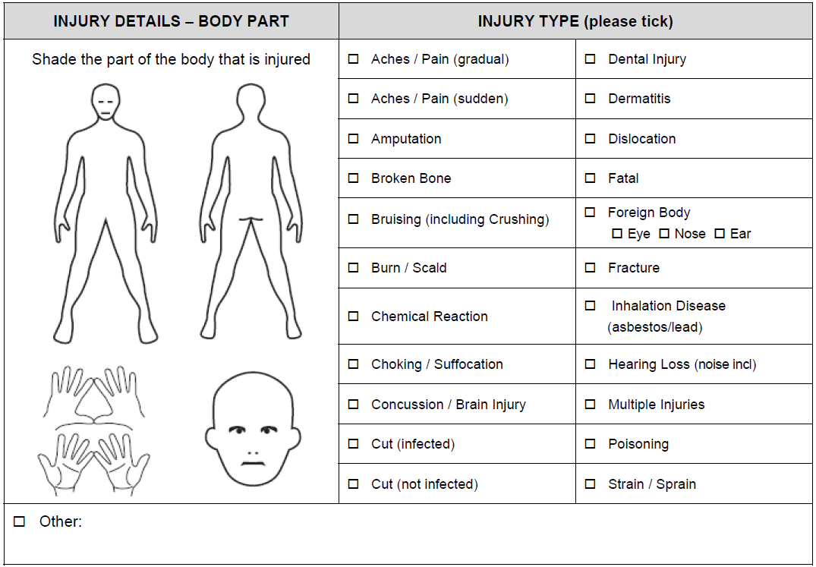
Reporting Process:
- Complete this form
- Hand over to Event Manager
- Manager to provide a copy to Governance / Overseeing Manager and keep a copy on record

**if an injury has occurred, please notify your manager verbally or by email as soon as possible.

